Financial Performance Analysis
(FY 2024–2025)
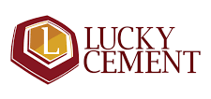

A comparative overview of Lucky Cement’s key financial ratios, profitability trends, and market indicators between FY 2024 and FY 2025.

By
Kashaf Afzal

Introduction:
Lucky Cement Limited, also known as Lucky Group, is a Pakistani conglomerate headquartered in Karachi, Sindh. Named after the place, Lakki Marwat, where the first plant was commissioned in 1993, Lucky has become one of the largest cement producers in Pakistan. It has 15.3 million tonnes per annum of manufacturing capacity. The company is listed on the Pakistan Stock Exchange.
Lucky Cement Limited was founded in 1993 by Abdul Razzak Tabba.
In 1994, Lucky Cement was listed on the Karachi Stock Exchange following an initial public offering.
It is one of four companies that collectively control 19.3% of the total market capitalization on the Pakistan Stock Exchange (PSX).
Purpose of Analysis:
The purpose of this analysis is to evaluate the financial performance and position of Lucky Cement Limited through ratio analysis. By examining key profitability, liquidity, efficiency, and solvency ratios over recent years, this report aims to identify the company’s financial strengths and weaknesses and assess its potential for future growth. Based on these findings, an investment recommendation (Buy, Hold, or Sell) will be provided.

Methodology:
The data for this analysis has been obtained from SCS Trade, which provides financial statements and market information for publicly listed companies in Pakistan. The study focuses on evaluating the overall financial health and performance of Lucky Cement Limited using ratio analysis.
The key financial ratios used in this analysis include:
These ratios have been calculated based on the company’s financial statements over the most recent three years to assess trends and provide an investment recommendation (Buy, Hold, or Sell).
Financial Ratio Analysis and Their Interpretation
- Liquidity Ratios:
Year | 2025 | 2024
Current ratio | 2.60 | 2.38
Quick Ratio | 1.64 | 1.55
Current Ratio: It increased (from 2.38 to 2.60), which shows that the company’s ability to pay short-term obligations has improved, it may have more current assets (Cash, inventory, receivables) or fewer short-term debts.
Quick Ratio: It also increased from 1.55 to 1.64, which shows that the company is now less dependent on inventory to meet its short-term obligations. This suggests improved liquidity and stronger ability to cover current liabilities using more liquid assets.
- Solvency (Leverage) Ratios:
Year | 2025 | 2024
Debt-to-Equity-Ratio | 87.96 | 68.25
Interest Coverage Ratio | 5.15 | 3.46

Debt-to-Equity Ratio: It increased from 68.25 to 87.96, which means that the company is now taking more debt compared to its equity, It became more leveraged (meaning higher financial risk).
Interest Coverage Ratio: It increased from 3.46 to 5.15, which means the company can cover its interest more easily, which is good.
- Equity Ratio:
Year | 2025 | 2024
Return On Assets | 10.55 | 9.94
Return On Capital Employed | 17.75 | 29.59
Return On Equity | 19.83 | 21.10

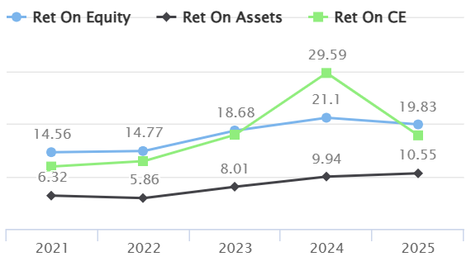
Return On Assets: It increased (9.94 to 10.55), indicating the company is earning more profit from the same amount of assets, which shows better efficiency in using resources.
Return On Capital Employed: It decreased (29.59 to 17.75), indicating the company is generating less profit from the capital it has invested.
Return On Equity: It went from 21.10 to 19.83 indicating less profit generated from equity, which can be due to less efficiency or overcapitalization.
- Efficiency Ratios:
Year | 2025 | 2024
Asset Turnover | 61.65 | 62.30
Inventory Turnover | 7.29 | 6.04

Asset Turnover: It went from 62.30 to 61.65, which means sales grew slower than assets, so assets are less efficiently used.
Inventory Turnover: It increased to 7.29 from 6.04, which means inventory is being sold faster, showing improved stock management.

- Profitability Ratios:
Year | 2025 | 2024
Gross Profit Margin | 27.30 | 30.05
Operating Profit Margin | 21.78 | 24.35
Net Profit Margin | 17.12 | 15.95

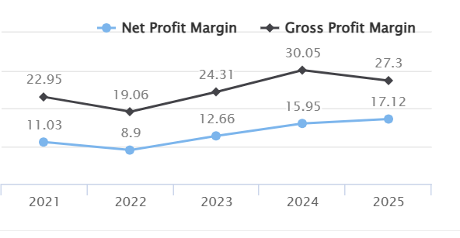
Gross Profit: It went from 30.05 to 27.30 which means cost of goods sold rose faster than sales, reducing gross margin.
Operating Profit: It decreased (24.35 to 21.78), which means higher expenses or lower sales caused operating profits to fall.
Net Profit: It increased (15.95 to 17.12), which means Other income, efficiency gains, or cost control improved overall profit.
- Investment Ratio:
Year | 2025 | 2024
Earnings Per Share (EPS) | 52.53 | 44.75
Dividend Per Share (DPS) | 4.00 | 3.00
Dividend Yield | 0.42 | 0.42
Price-Earnings Ratio (P/E) | 18.28 | 16.08
Dividend cover | 13.13 | 14.92

EPS: It increased from 44.75 to 52.53, which means higher net profit or fewer shares increased earnings per share.
DPS: It was 3.0 in 2024 and in 2025 it rose to 4.00 indicating more profit is distributed per share to shareholders.
Dividend Yield: It remained constant which means investors are still getting the same percentage return from dividends relative to the share price as before.
Price to Earnings (P/E): It increased from 16.08 to 18.28 which means market price rose relative to earnings, signaling higher valuation.
Dividend Cover: It went to 13.13 from 14.92 which means profits fell relative to dividends, reducing the safety margin for payouts.
Investment Recommendation (Buy/Hold/Sell)
Overall, Lucky Cement remains financially stable with rising earnings and dividends but increasing leverage calls for caution.
Recommendation: Hold / Moderate Buy good for investors seeking steady returns with moderate risk.

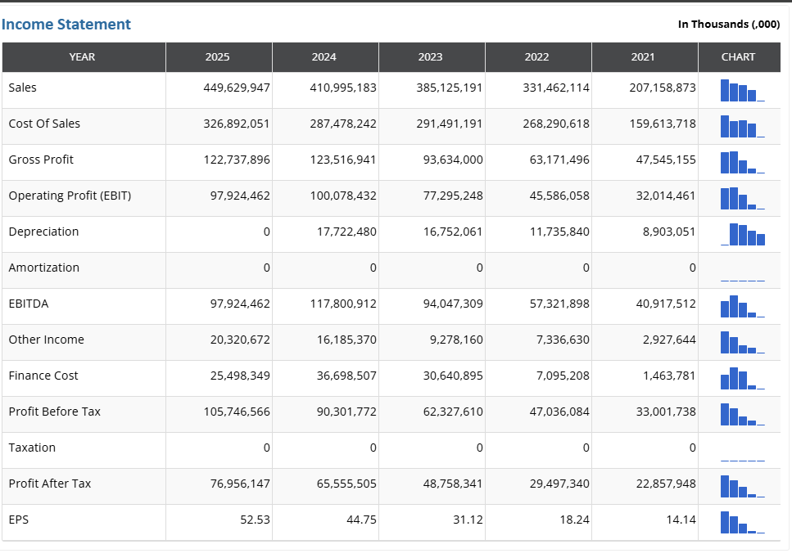
Financial Statements

